Analysis Questions:

What is the correlation (R2 value) between sales and income?

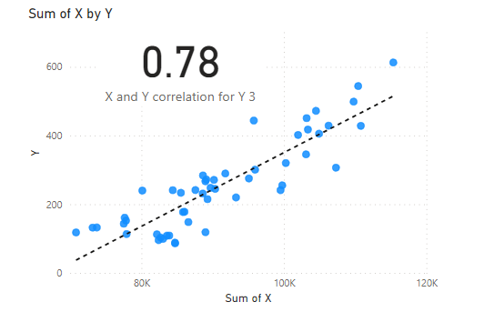

What is the correlation (R2 value) between customer ratings and product return rate?

What are the linear regression formulas to predict customer income from customer sales?

Which customer do you predict has the highest income?

Which product will be advertised the most?

in most adv it shows the shirt is the most product get adv